УДК 338.45:634

Osipova Elena Andreevna – graduate student of the Far-Eastern institute of management – branch of RANEPA (Khabarovsk). E-mail: osipova.elena92@gmail.com

Assessment of tendencies of development of the region's forest complex
in the context of sustainable development requirements

The article analyzes the main tendencies of development of forest complex of the Khabarovsk Territory and the activities of forestry companies in the context of sustainable development. Based on the statistical data the author consider economic, ecological and social projection of sustainable development of the forest complex. In the course of the analysis revealed that the development of forest complex of the Khabarovsk Territory is unstable. Despite the fact that government implemented priority investment projects of the processing harvested timber, created areas of advancing socio-economic development the economic condition of the forestry companies and the forestry industry remains extremely difficult. There are many problems corresponding to the extensive growth of the timber industry of multi-wood region than for the sustainable development. All of this should be consider when public authorities of the regions designing policies for sustainable development of the forest complex and forestry companies, the development of the strategy and objectives of the forest complex.

Оценка тенденций развития лесного комплекса региона в контексте требований устойчивого развития

В статье проанализированы основные тенденции развития лесного комплекса Хабаровского края, деятельности лесопромышленных компаний в контексте устойчивого развития. На основе статистических данных рассмотрены экономическая, экологическая и социальная проекции устойчивого развития лесного комплекса. В ходе проведенного анализа выявлено, что лесной комплекс края развивается нестабильно. Несмотря на реализуемые приоритетные инвестиционные проекты по развитию переработки заготавливаемой древесины и создание территорий опережающего социально-экономического развития, экономическое состояние лесопромышленных компаний и отрасли в целом остается крайне сложным. Сохраняются проблемы, характерные в большой степени для экстенсивного роста лесной промышленности многолесного региона, чем для устойчивого развития. Все это необходимо учитывать при разработке органами государственной власти Хабаровского края политики по обеспечению устойчивого развития лесного комплекса и лесопромышленных компаний, входящих в его состав, выработке стратегии и целей деятельности лесного комплекса.

Keywords: sustainable development of forest complex, socio-ecological-economic development, sustainable development offorestry company.

Ключевые слова: устойчивое развитие лесного комплекса, социально-эколого-экономическое развитие, устойчивое развитие лесопромышленной компании.

In modern conditions, the transition of the forest complex management to the principles of sustainable development is a necessity due to the intensification of the interaction between the economy and nature significantly affect the environmental consequences of the production, and absolute and relative scarcity of forest resources. Sustainable development of forest complex is a long-term environmentally adaptive, social-oriented and economical effective interaction between human and forests [1, 2].
At the same time, the main subject of sustainable development of forest sector should be the company as its key elements. In this regard, relevant is the assessment of trends in the development of forest complex of the Khabarovsk Territory, the activities of forestry companies in the context of sustainable development requirements, providing an analysis of the economic, social and forestry-ecological projections.
The forest complex of the Khabarovsk Territory occupies an important place in the economy of the region, being one of the areas of its specialization. The area of forest fund of the region is 73,7 million hectares (93,5% of the territory of the region). Timber reserves in the Khabarovsk Territory estimated at 5.1 billion of cub. m., which is 25.5% of the stock of the Far East and 6.6% of the stock of the Russia [3].
Forest complex of the region consolidated, represented by large forestry holdings. Such vertical integration of forestry companies causes a synergistic effect that manifested in the flexibility and efficiency of business, has a strong influence on competitiveness [4]. The industry also employs about 260 small and medium-sized businesses; the share of commodity products is about 20%.
Considering the economic projection of the forest sector development, should note that according to the results of the industry for the period 2000 – 2015 have seen irregular trend of oscillation of indexes of timber production (fig.1).In the dynamics, there are clearly visible periods of declines and increases of production. In 2008, 2013 marked a sharp decline as logging and timber processing, due to the crisis that taking place in these periods in the industry and the economy not only of Khabarovsk Territory, but also in Russia as a whole.
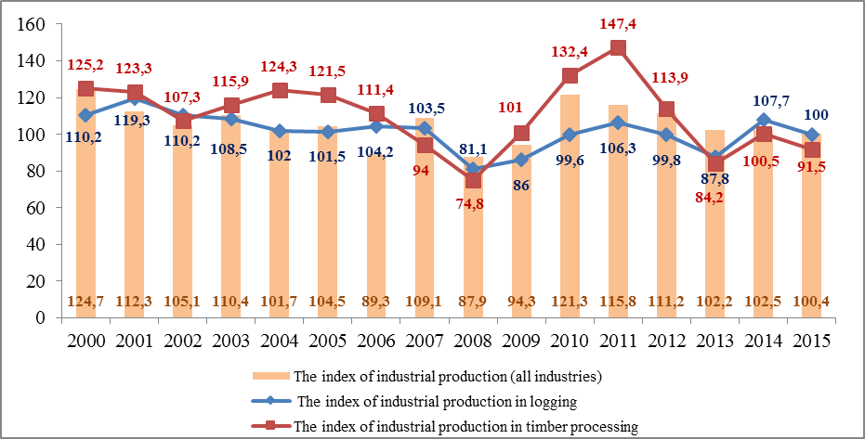
Fig. 1. The dynamics of indexes of industrial production, % to the previous period

Since the beginning of the implementation of priority investment projects in the field of timber processing (2008) in the forest sector of the region's economy has managed to attract more than 35 billion rubles of investments, additionally created capacities for processing 3.2 million cub. m of wood. All of this favorable impact on the growth of the index of industrial production in timber processing.
The dynamics of logging and timber processing in the region from 2011 to 2013 was negative; in 2014, the situation began to change for the better. However, by the end of 2015 as there is a regular decrease in the indices of industrial production. In 2015, the index of industrial production of logging amounted to 100%, the index of industrial production of timber processing is 91.5%, which is less than in the previous period by 9 percentage points.
In 2016, another increase of timber processing is expected. That is associated with the beginning of the implementation of projects within the advancing social economic development territories (ASEDT).Therefore, a new project for deep processing of wood of holding "RFP Group", included in the list of residents of ASEDT "Komsomolsk" on site "Amursk", focuses on the integrated use of low-grade wood, secondary raw materials and waste production. A decision on the creation of the Far East timber cluster, adopted at the II Eastern Economic Forum (September 2 – 3, 2016), will promote the development of forest resources of the region and an increase in production capacity for wood processing.
Despite all the implemented investment projects and initiatives in the forest complex structure is still dominated by logging (Fig.2.), indicating that the low proportion of timber processing. In 2014, the share of timber processing in the total volume of timber harvested in the region was 34.7%, which is not fully consistent with the principles of sustainable development.
Despite the growth of timber processing, in the total volume of processed timber products high proportion of lumber (in 2013 the share of lumber accounted for 41% of all treated wood) [9]. Therefore, the edge woodworking industry represented mainly by products with a shallow level of processing, which also runs counter to the principles of sustainable development.
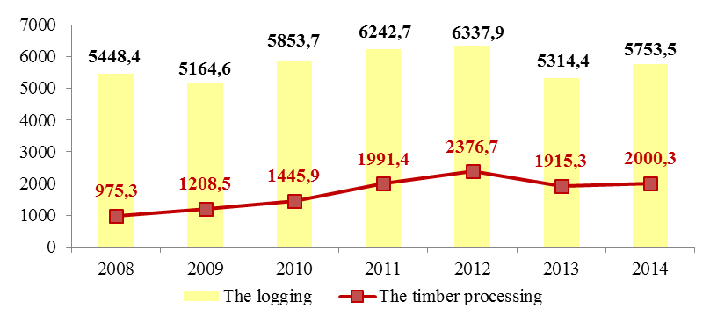
Fig. 2. Dynamics of logging and timber processing, thousands of cub. m

The economic efficiency of the forest complex of the region is reduced. So profits and added value to 1 cub. m of wood hauling is reduced; product unit cost, capital-intensiveness, product real wage of 1 cub. m of timber is growth [10]. In 2014, the cost of 1 cub. m of logs increased by 15.8%, 1 cub. m of lumber increased by 19.7%.Expenses forestry companies at a production and sales increased by 9.6%. Profitability of production was negative.
In general, the financial condition of forestry companies of the region is poor. In 2012, 61.8% of logging enterprises and 77.8% woodworking companies were unprofitable. In 2014, 50 enterprises of the industry (28.9%) were unprofitable. Rimbunan Hijau MDF LLC, Rimbunan Hijau International LLC, Rimbunan Hijau DVLLC, JV Arkaim LLC, Dallesprom Leader LLC, Gorinskiy LPHJSC and the others incur losses.
Such financial condition of enterprises explained that the timber industry of regions is traditionally export-oriented and dependent on demand for timber from external customers. The instability of the dollar has a negative impact on the financial and economic situation of businesses with credit commitments in foreign currency attracted for the implementation of priority investment projects.
At the same time, low availability of bank loans to forestry enterprises plays an important role. In the Russian commercial banks forestry enterprises of the region attributed to high-risk groups [3].In view of the proposed credit conditions, timber companies refrain from attracting credit resources of commercial banks and work on terms of pre-payment of regular consumers of manufactured timber products, which in turn affects the price decline.
In addition, a major challenge for sustainable development of forest complex remains limited of domestic market of timber. Of the total volume of product sales of forest complex, proportion of the domestic market does not exceed 4-5%. [8]Deliveries of production in the western regions of the Russian Federation are unprofitable because of high railway tariffs and the lack of opportunities to compete with other manufacturers of similar products, the timber growing in the western regions.
Considering the investment component of the sustainable development strategy, we note that the structure and dynamics of attracting investments in the forest complex of the Khabarovsk territory shows in general an increase in capital investment in timber processing from 2009 to 2011and in 2014, where a volume of investment in wood processing reached a record to 94.9% (Fig. 3).However, the overall level of investment in 2015 decreased significantly by 61.0% (3.6 billion rubles) to the level of 2014 and by 66.7% (4.6 billion rubles) compared to 2009 and amounted to 1.9 billion rubles. Not a high share of capital investments in the wood processing and demonstrates the need for reorientation of forest sector development with the principles of extensive development at the principles of sustainable development.

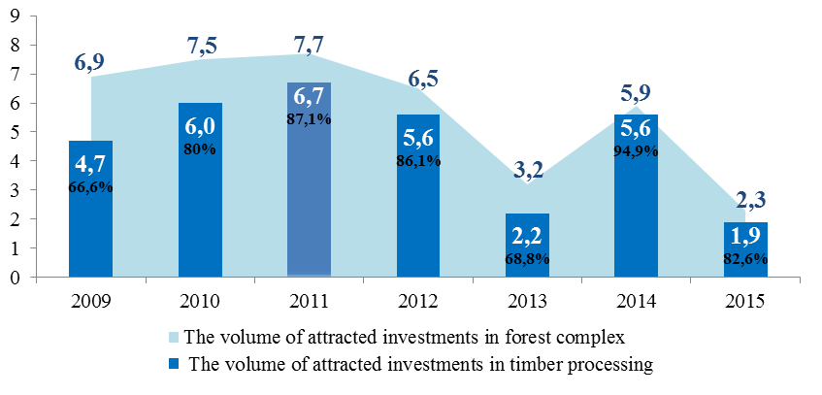
Fig. 3. Dynamics of attracting investments in the forest complex of the region and their structure

Thus, in the forest complex of the region the level of economic efficiency is low, although the certain investment preconditions laid down (priority investment projects, ASEDT, timber cluster) for the implementation of projects on complex processing of timber. Because the economic projection is the basis of sustainable development, without increasing the economic efficiency of forestry companies is impossible to talk about sustainable development of the forest complex.
After analyzing the main economic indicators of development of the timber industry of the region is necessary to stop at the forestry and ecological projections of sustainable development. In recent years, in the region has developed a steady tendency to reduce the amount of work on reforestation, forest management, forest protection from diseases and fires. In 2014, the work of reforestation decreased by 36.2% to the level of 2008 and by 13.5% to the level of 2008.
Over the past five years, correlation the area of artificial reforestation and area of clear cuts of forest stands on forest land of the region has decreased by 1.4 percentage points from 10.7% to 9.3% (fig. 4). The intensity of forest management also is very low. It is estimated, that removal of industrial wood from 1 hectare of covered area, on average, is in the forests of the third group of 0.12 cub. m, in the country – 0.20 cub. m. [1, 12].
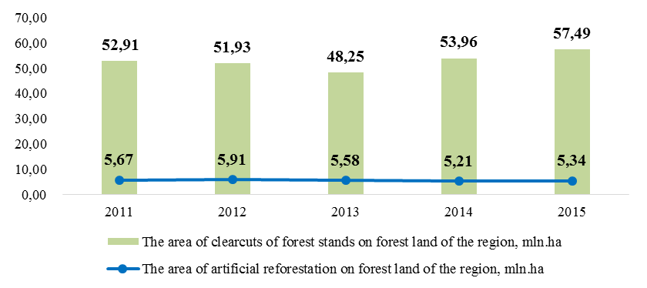
Fig. 4. Correlation the area of artificial reforestation and area of clear cuts of forest stands on forest land of Khabarovsk Territory
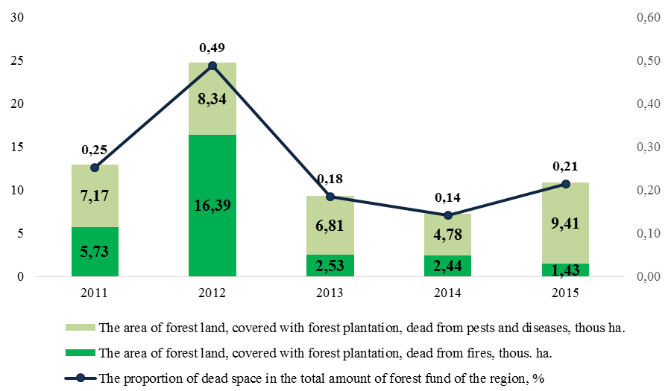
Fig. 5. The area of forestland covered by vegetation, dead from pests
and diseases

Despite the fact, that in 2013-2015 there is a slight increase in the area of forest plantations, its rate of growth is less than the rate of growth of the total area of wooded land of forest fund (Fig. 5).In 2015, the proportion of the area of forest plantations as part of wooded land of forest fund of the region was 76.1%, while in 2011 it was 76.3%.In general, these trends are typical for the extensive growth of the timber industry of the multi-wood region, rather than sustainable development.

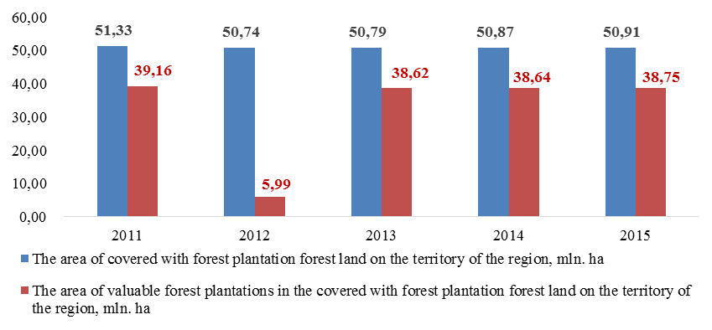
Fig. 6. Correlation the area of valuable forest plantations and the area of forest plantations at a wooded forest land in the Khabarovsk Territory
Source: Calculated by the author according to the data by Government of Khabarovsk territory

An important role in the development and maintenance of forests plays a well-developed forest transport infrastructure. Poor transport security of industry creates a problem for its development. Long-distance of wood hauling, low density of road network, transport inaccessibility of the northern districts of the region determine the seasonal harvesting, form high transport costs, reducing the profitability of timber [10].In the cost structure of forest enterprises rail transportation of raw materials and timber occupies up to 40%, making economically inefficient delivery of timber and forest products from remote databases of forest or the creation production capacity for wood processing [3].
Every year in the region under a third of needs of roads built. Along with this concern cause operational and performance characteristics of logging roads. Of the existing main logging roads (about 4.6 thousand km) a significant part at the present time lost operational characteristics and requires modernization. Many businesses completely stopped construction of logging roads of year-round action. All of this adversely impact on the value of wood removals, time required for this, and also complicates the possibility of a rapid response to the threat of forest fires. For the full exploit, the identified in the use of forest resources to 1.0 thousand km of roads with year-round the action should be built annually, and their total length should reach 11-12 thousand km [3]. The development of forest infrastructure, including the construction of a network of forest (logging, forestry, fire prevention) roads is an important condition for sustainable development of the timber industry, both in the short and in the long term.
The social projection problem of skills shortages is the deterrent to the sustainable development of forestry companies. Currently, the need for enterprises of forest complex of Khabarovsk territory is about 600 people; about 30% of them are qualified experts, engineers and technical workers. [3]
In 2014, the number of employees in forest complex of the region was 15.47 thousand people, which is less than in 2013 by 6.8%.Reducing the total number of employees was due to the decrease in the activity of such large enterprises like JV Arkaim LLC and Rimbunan Hijau Group, which are on the verge of bankruptcy.
The average monthly salary at the enterprises of forest complex of the region shows an increasing trend since 2008.At the same time, the wages of workers in logging is higher than the wages of workers in the timber processing companies (Fig.7).Despite the positive trend, the average monthly wage in the forest complex is significantly lower than the average monthly wage in all sectors of the economy of the region. In general, the low level of wages in the industry is characterized by low productivity of workers. This is evidenced by the ratio of the growth rate of the average wage of workers in the industry and average output per worker (Fig. 8).It should be noted that in 2012 production growth rate exceeded wage growth rate by 21.8 percentage points, in 2013 – 2014 the situation has leveled off.
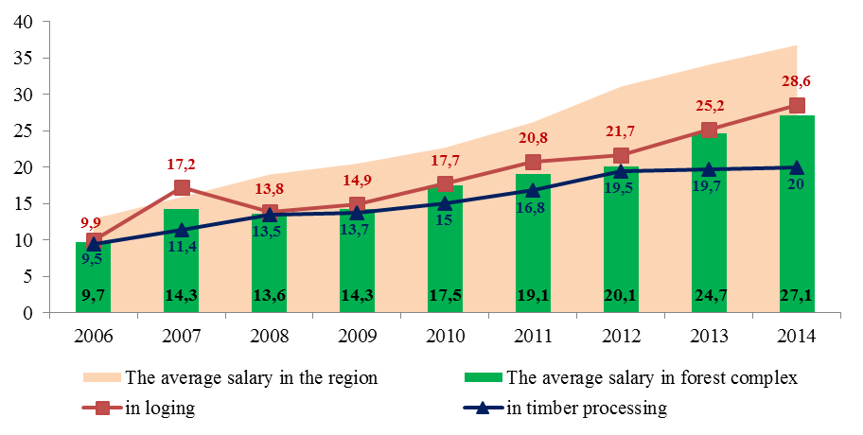
Fig. 7 - Dynamics of the average monthly wage of 1 employee in forestry companies of the region, thousand rubles.
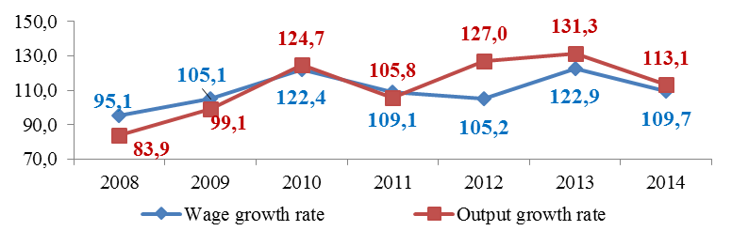
Fig. 8. - The pace of growth of the average wage of 1 employee and the average output of 1 employee
Source: Calculated by the author according to [5,6,8]

However, it is worth paying attention to the fact that the rate of growth of output per worker exceeds the rate of growth of wages since 2012. This ahead of the curve indicates an increase in maintenance of personnel. However, in the social projection of sustainable development of forest complex can be identified some positive trends. Thus, the share of the wage bill of sales of timber companies has increased from 14.4% (in 2008) to 20.3% (in 2014).As for social protection of employees, the fund of monetary assets spent on financing of measures the social orientation of the enterprises is quite moving, as formed by each company by itself from its own funds in response to the current economic situation.
Analyzing the main trends of development in the forest complex of the region and forestry companies was found that the timber industry is unstable developing. Despite the implemented priority investment projects on development of the processing of harvested wood, the financial and economic state of the industry remains extremely difficult. Companies were in an unstable financial situation formed as a result of shortage of circulating assets for current operations and for the fulfillment of obligations on maintenance involved for implementation of priority investment projects credit resources.
Among the problems that hamper the sustainable development of the industry and forestry companies also can distinguish a decrease forest productivity; the lack of transport infrastructure in a remote location of the forest areas and villages, low-maintenance and speed characteristics of forest roads; reduction in the number and quality of works on reforestation; lack of qualified personnel and increased degree of exploitation of employees; limited domestic timber market and dependence on exports and etc. These problems need to be considered in the development of management policies for the sustainable development of the forest sector and forestry companies, strategies and goals. The consistency of socio-environmental and economic objectives and performance indicators is possible at application of the Balanced Scorecard as a strategic management tool.

Literature and the sources:

- Резанов, В. К. Адаптивное управление трансформацией и развитием лесопользования / В. К. Резанов. – Владивосток : Дальнаука, 2001. – 351 с.
- Механизмы управления устойчивым развитием лесного комплекса / В. К. Резанов [и др.] ; под ред. В. К. Резанова. – Владивосток : Дальнаука, 2015. – 511 с.
- Распоряжение правительства Хабаровского края от 12.12.2015 г. № 942-рп "О ходе выполнения Постановления Правительства Хабаровского края от 08 августа 2012 г. № 266-пр "Об основных направлениях развития лесной отрасли Хабаровского края на 2013 – 2015 годы и на период до 2020 года" и об утверждении комплексной региональной программы "О развитии лесопромышленного комплекса Хабаровского края до 2020 года"[Электронный ресурс] : официальный сайт нормативно-правовых актов Хабаровского края – . – Режим доступа: http://laws.khv.gov.ru/pdf/%D1% 80%D0%BF_00942_12122015_000.pdf?v=0,5038446
- Резанов, В. К. Алгоритмы и механизмы управления интеграционным развитием лесного комплекса / В. К. Резанов, В. М. Шихалев. – Хабаровск : Изд-во Тихоокеан. гос. ун-та, 2010. – 304 с.
- Лесопромышленный комплекс края в современных экономических условиях : статистический сборник (с обзором) // Хабаровскстат. – Хабаровск, 2013 – 29 с.
- Лесопромышленный комплекс края в современных экономических условиях : статистический сборник // Территориальный орган Федеральной службы государственной статистики по Хабаровскому краю. – Хабаровск, 2008. – 22 с.
- Лесопромышленный комплекс края : аналитическая записка // Хабаровский краевой комитет государственной статистики. – Хабаровск, 2003. – 16 с.
- Лесопромышленный комплекс Хабаровского края в цифрах и фактах [Электронный ресурс] –.– Режим доступа: http://www.kp.ru/best/ hab/les/
- Резанов, В. К. Стратегическое планирование устойчивого развития компании на основе ресурсно-рыночного подхода / В. К. Резанов, Е. Ю. Дюйзен. – Хабаровск : Изд-во Тихоокеан. гос. ун-та, 2015. – 209 с.
- Резанов, В. К. Интегрированная модель системы сбалансированных показателей лесного комплекса (синтез подходов, комплексный анализ, интегральная оценка) / В. К. Резанов, М. В. Шабалина. – Хабаровск: Изд-во Тихоокеан. гос. ун-та, 2011. – 239 с.
- Постановление Правительства Хабаровского края от 08.08.2012 №266-пр «Об основных направлениях развития лесной отрасли Хабаровского края на 2013 – 2015 годы и на период до 2020 года» [Электронный ресурс] : официальный сайт нормативно-правовых актов Хабаровского края –.– Режим доступа: http://laws.khv.gov.ru/pdf/%D0%BF%D0%BF_00266_0808 2012_000.pdf?v=0,28144
- Резанов, В. К. Комплексная оценка устойчивого развития лесного комплекса: выявление трендов и анализ стратегий / В. К. Резанов // Власть и управление на Востоке России. – 2011. – № 1 (54). – С. 46 – 54.

