УДК 316.4.057.4

Tatyana Vladimirovna Barmina – Candidate of Psychology, docent of the sociology, social work and right chair of the Far-Eastern institute of management – branch of RANEPA (Khabarovsk). E-mail: barminat@mail.ru
Elena Vyacheslavovna Tolkachyova – Candidate of Sociology, docent of the sociology, social work and right chair of the Far-Eastern institute of management – branch of RANEPA (Khabarovsk). E-mail: e-v-tolkacheva@ya.ru

Deinstitutionalization of a social orphanhood: social and psychological aspects

In this article methodological approaches to a concept of category of deinstitutionalization of an orphanhood are analyzed, based on what theoretical idea of the essence of deinstitutionalization of an orphanhood and a social orphanhood is offered that allowed interpret, describe and explain more precisely empirically a number of the observed phenomena in the sphere of guardianship of the orphan children and the children without parental support. Besides, the problems of deinstitutionalization of a social orphanhood are reflected in a new judgment, conclusions are drawn on the effectiveness of managerial impact and the prospects of its enhancement are designated.

Роль исследования отказа от материнства в решении проблем
социального сиротства

В статье рассматриваются социальное сиротство как феномен отказа от материнства, его проявление в системе социальных отношений, а также возможные формы отказа от материнства. Изложены теоретические представления о материнстве как самостоятельной социальной реальности, особое внимание уделяется девиантному материнству. Приведен анализ результатов исследования проблемы отказа от материнства как одной из основных причин социального сиротства. На основе анализа официальной статистики и результатов социологических опросов авторами установлено, что, несмотря на наметившуюся тенденцию снижения всевозможных форм отказа от материнства, в современном российском обществе проблемы: пренебрежение материнскими обязанностями, эмоциональная холодность, нежелание нести груз ответственности за воспитание детей – остаются глобальными. Это актуализирует потребность более детального исследования данного феномена с учетом современных гендерных представлений, а также требований современного общества в целях профилактики социального сиротства.

Keywords: deinstitutionalization, deinstitutionalizations of a social orphanhood, orphan children and children without parental support, social orphanhood, device forms, residential care facilities, social and psychological adaptation.

Ключевые слова: социальное сиротство, социальное сиротство как феномен отказа от материнства, материнство, девиантное материнство, отказ от материнства, личностные и социетальные факторы.

In the modern society the problem of protection of orphan children and children without parental support, arise owing to the different reasons. First, children owing to the age have limited opportunities in the independent planning optimum for the activity and development of the environment conditions. It is connected as with the biological and mental features of the children's age. Secondly, children are considered as the potential, the social allowance planned to provide in the future stability and development of the society. Thirdly, concerning the orphan children and children without parental support, the set of the stigmata which are negatively influencing a social position of this category is created, it is especially heavy in this plan to the children with the limited opportunities of health.
There is no need someone today to convince of a need of special social security and the device of orphan children and children without parental support. The strategy of help to the children of this category adopted in Russia for many years consisted mainly in placement them in the residential care facilities. However the conditions of accommodation of children in orphanage or in similar organizations limit contacts with the outside world and are insufficient for acquisition of the own experience. The low level of social competence peculiar to orphan pupils, breaks the process of social and psychological adaptation, their inclusion in the society life subsequently, reduces a possibility of assimilation of the accepted value system, regulations, values and representations. In case of an exit from the walls of organization of public education the orphan child will experience great difficulties, having touched the independent life. Development by orphan children and children without parental support, social experience, inclusion in the existing system of public relations demands from the society certain additional measures, means and efforts, including in the questions of social and psychological adaptation.
Recently the changes reflected in the policy of deinstitutionalization of orphan children and children without parental support who allow break down the developed stereotypes in relation to the status "orphan child", and also to a problem of deinstitutionalization of a social orphanhood are observed.
It should be noted that deinstitutionalization concerning the problems of orphans and an orphanhood repeatedly was considered in the works of N. Zaytseva [1], O.V. Besschetnova [2], N.M. Baykova [3]. In addition, the process of deinstitutionalization within the social and psychological approach as a process of reforming of the social relations in the residential care facilities was investigated in the scientific works of Yu.A. Volodina, L.D. Gulina, V.N. Oslon. In particular, O.V. Besschetnova suggests to understand the process of deep transformation and destruction of the developed social relations as a process of deinstitutionalization of an orphanhood.
Nevertheless, treating the de prefix as cancellation or reduction, process of deinstitutionalization of an orphanhood appears at us in the other understanding – as a process directed to destruction of the existing practice of an orphanhood, reduction of a number of orphans, elimination from the use of the concept "orphan", but not just movement of this category of children from the residential care facilities in the families. As in the latter case it is rather about deinstitutionalization of the state support of orphan children which assumes "replacement" of the institute of residential maintenance by the institute of a foster home. Thus, deinstitutionalization of an orphanhood isn't identical to a concept of deinstitutionalization of the state support of orphans and, respectively, has to have the other treatment and contents, than those which revealed in the works of the above-mentioned scientists.
Let's begin with the fact that the processes of deinstitutionalization of an orphanhood include the processes of formation of the institutes of scheduled maintenance with the families, adoption and return to the seven children, and in a broader sense – elimination the the practices of an orphanhood. Thus, considering the processes of deinstitutionalization of an orphanhood, we can characterize only success or not success of their course during these or those historical periods. At the same time, it should be noted that the processes of deinstitutionalization of an orphanhood and social orphanhood have different contents. So, for example, the scheduled maintenance on prevention of an orphanhood owing to the death of parents may contain a complex of actions for the decrease in maternal mortality, mortality in the road accidents, labor protection, health protection etc. Concerning the other category of children - social orphans is a prevention of family trouble, refusals of children in the maternity hospitals, return of children to the families. The important deinstitutsionalization process concerning both groups of orphans is a process of adoption and its stimulation.
Thus, the main objectives of this research: studying and efficiency analysis of the state policy in the field of deinstitutionalization of a social orphanhood; identification of contradictions and reasons generating them; development of recommendations about the enhancement of this direction of activities of the agencies of guardianship, social protection and education.
It should be noted the contradictions observed at the moment: growth of the persons interested to adopt children in the case of decrease in the number of adopted, decrease in the number of adopted children in the case of increase in the number of children suited in the foster homes. At the same time, the problem of deinstitutionalization of an orphanhood can be solved only by providing the rights of children to a family when the child loses the status of the orphan child or child, without parental support, in the case of return to a family or adoption.
In the Russian Federation since 2005 the downward tendency of again revealed orphan children and children without parental support is observed. In 2015 the number of the revealed orphan children and children without parental support, made 58168 people [4] that is 2,28 times lower than the similar indicators for 2005 (fig. 1). In general, the number of again revealed orphan children and children without parental support during the period from 1993 to 2015 hesitates. For the specified period two maxima – in 1994 and 2005 when the number of the revealed orphan children and children without parental support, made, respectively, 126322 both 133034 people, and two minima – in 1997 and 2015 are observed. Respectively, the process of identification of orphan children and children without parental support, is an oscillatory process. Proceeding from this representation, in a situation of recession shown since 2005 it is possible to predict growth of the number of again revealed orphan children and children without parental support which is coming in the next years.

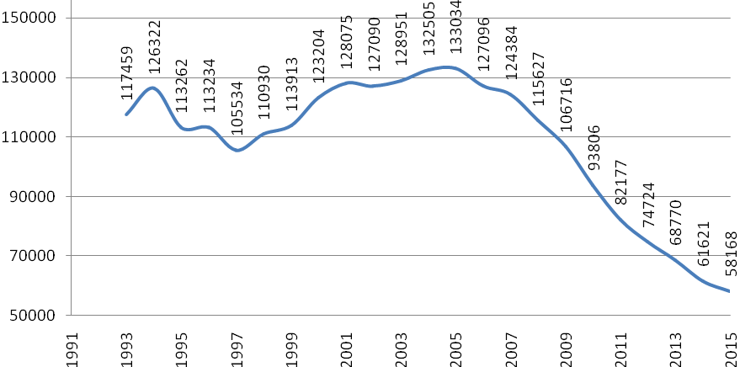

Fig. 1. The number of again revealed orphan children and children
who have remained without the care of parents, in the Russian Federation

A row of social factors of political, standard and social and economic nature influenced the current situation. At the same time, the extent of connection of demographic factors, in particular the total number of children, and also the number of children of teenage age and again revealed orphan children and children without parental support, is provided as follows. During the period from 2005 to 2015 when the steady recession of a number of again revealed orphan children and children without parental support, connection of this indicator with the indicator reflecting the number of the children's population during the researched period, is observed. Thus, growth of a number of the children's population observed in the recent years, in particular the teenage age, naturally in the next several years will affect the growth of a number of again revealed orphan children and children without parental support.
At the same time, by the results of correlation analysis of the revealed orphan children and children without parental support, and also data on a birth rate of the population to a number in the Russian Federation for 1995 − 2015 the average return correlation connection with high degree of the importance (coefficient of correlation – 0,76) was received, which shows connection between the growth of birth rate of children and decrease in a number of annually revealed orphan children and children without parental support. As since 2005, according to the Russian statistical year-book, in Russia increase in a number of newborn children is observed, it is possible to make the assumption of influence on the decrease in a number of again revealed orphan children and children without parental support, the same factors which promote the birth rate growth.
At the same time, the processes of identification of children without parental support, for the reasons of deprivation or restriction of parents in the parent rights have the negative dynamics: the number of this category of children was reduced since 2008 almost twice (fig. 2). At the same time, the share of children whose parents were deprived or limited in the parent rights from the total number of orphan children and children without parental support, increased with 0,7 in 2008 to 0,85 in 2015. This specifies insufficient effectiveness of the process of deinstitutionalization of a social orphanhood on the analyzed indicator.

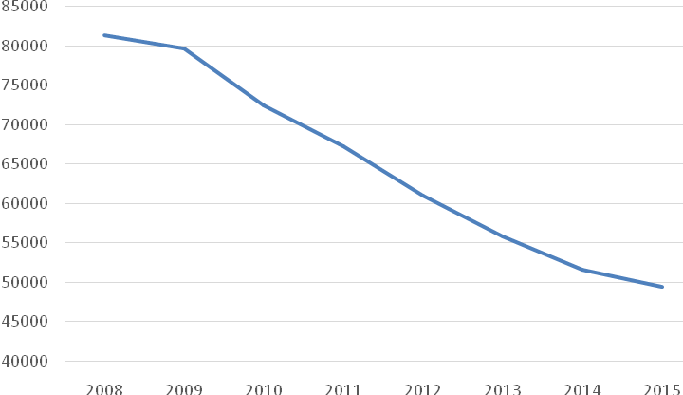

Fig. 2. The number of children whose parents have been deprived or limited
in the parental rights in the Russian Federation

The processes of deinstitutionalization of a social orphanhood assume broad scheduled maintenance with the families on prevention of emergence of the adverse life situations which can lead to a social orphanhood.
Consolidation of regional services in the organization of psychological, public, medical, legal assistance in the problem resolution of orphan children and children without parental support, allows give the complex address help to a family and to a child, effectively to the structure system of functional management of the corresponding services.
Application of foreign methods of work in the problem resolution of a social orphanhood will allow create and realize the projects of primary and secondary socialization of orphan children, to develop innovative models and forms of their device, the program implementation on protection of a family and the childhood, prevention of a social orphanhood.
Accounting of the age and psychological features of orphan children promotes determination and use of the most effective forms of deinstitutionalization of a social orphanhood, rendering the social maintenance to the crisis families with the purpose of prevention of hit of children in the organizations of public education, to providing of medico-social support of the orphan children at the different stages of development and by that leads to the successful psychologycal-social adaptation, preparation them to an independent life in the society.
Determination of priority measures for the social and psychological adaptation of orphan children and children without parental support, allows prepare the perspective plan of their psychological-social adaptation on assimilation of cultural regulations and values, family traditions, does more transparent the status of "orphan child" that promotes acceptance by his surrounding social environment.
As the negative tendencies of the processes of deinstitutionalization of an orphanhood it is possible to note the decrease in the number of adopted children with the observed growth of a number of persons interested to adopt in Russia.
In total from 1993 for 2014 citizens of the Russian Federation adopted 186326 children. The minimum number of adopted children – 5903 people – falls on 2015, the maximum quantity – 14179 – for 1994. In the empirical researches based on the sociological surveys of opinion of the population conducted by VCIOM in 2005, 2013, 2015 in Russia it was noted that, according to respondents, the insufficient level of income is a basic reason of unwillingness to adopt children: "… Reflecting over the conditions which would allow adopt the child, Russians most often specify availability in the family of material prosperity (15% of Russians; in 2005 mentioned it significantly more often − 31%). Important factors are also recognized: absence of children (10%), good housing conditions (8%) and availability of the state support (8%). For 3% adoption is possible if it is a child of native or good acquaintances. Less significant factors: availability of desire and free time (2%), the state of health of the child and adoptive parents, a consent of family members, availability of a complete family (on 1%). 13% note that adoption for them is impossible under no circumstances [5]".
The analysis of influence of welfare of the population of Russia on the number of adopted and sponsored children showed the following: correlation connection between the number of adopted children and the relation of size of a subsistence minimum to the average salary in the country during the period from 1993 to 2013 extremely low (the coefficient of correlation of Pearson makes-0,197). It specifies the fact that during the period from 1993 to 2013 welfare of the population of Russia has no significant effect on the number of children adopted by the citizens of the Russian Federation. Indicator are 1993, 1994 and 1995 when in our country the record figures of children adopted by the citizens of the Russian Federation are fixed, and also 2007 in which the biggest was fixed over the last 10 years the number of children adopted by the citizens of the Russian Federation, at the same time, the relation of size of a subsistence minimum to the average salary about the country by 1,16 times was below the similar indicator of 2012 in which the lowest level of adoption of children by the citizens of the Russian Federation, since 1993 is fixed. Thus, being based on the obtained analytical data, it is possible to call into question positive influence of the growth of level of economic welfare of the population on the growth of number of adopted orphan children and children without parental support.
At the same time, we see the influence of the state policy on development of the institute of foster home and insufficient attention to the processes of functioning of the institute of adoption of orphan children and children without parental support. According to the regression analysis, during the period from 2000 to 2014 the most intensively influence on the number of orphan children and children without parental support who are in the residential care facilities rendered functioning in Russia of the institute of foster home. It should be noted that the share of orphan children and children without parental support who are in the residential care facilities is reduced in recent years, at the same time, the share of orphan children suited in the foster homes – grows. These forms of living and education are similar that the activities for leaving and education of children in both cases are paid with the state, at the same time, the costs for education of children in foster homes, certainly, below the charges of children in the residential care facilities.
The results of calculation of shares of the children who are in the residential care facilities, the children who are under the non-paid guardianship and adopted and also the children in the foster homes from the total number of orphan children and children without parental support from 2000 for 2014 are reflected in the table 1.
Table 1

Distribution of the shares of orphan children and children without parental support, in the different forms of living from the total number of orphan children and children without parental support [6]

Year | share of children in the boarding schools | share of children in the foster homes | share of the adopted children | share of the sponsored children | share of children in the gratuitous forms | the sum of shares of children in the boarding schools and in the foster homes
2014 | 0,12 | 0,21 | 0,20 | 0,48 | 0,67 | 0,33
2013 | 0,14 | 0,18 | 0,19 | 0,48 | 0,68 | 0,32
2012 | 0,16 | 0,15 | 0,19 | 0,50 | 0,69 | 0,31
2011 | 0,16 | 0,14 | 0,19 | 0,51 | 0,70 | 0,30
2010 | 0,18 | 0,12 | 0,19 | 0,51 | 0,71 | 0,29
2009 | 0,18 | 0,10 | 0,20 | 0,52 | 0,72 | 0,28
2008 | 0,19 | 0,08 | 0,20 | 0,53 | 0,73 | 0,27
2007 | 0,21 | 0,05 | 0,21 | 0,53 | 0,74 | 0,26
2006 | 0,22 | 0,03 | 0,21 | 0,54 | 0,75 | 0,25
2005 | 0,23 | 0,02 | 0,21 | 0,54 | 0,75 | 0,25
2004 | 0,24 | 0,01 | 0,21 | 0,54 | 0,75 | 0,25
2003 | 0,24 | 0,01 | 0,20 | 0,54 | 0,75 | 0,25
2002 | 0,24 | 0,01 | 0,20 | 0,55 | 0,75 | 0,25
2001 | 0,24 | 0,01 | 0,20 | 0,55 | 0,75 | 0,25
2000 | 0,24 | 0,01 | 0,20 | 0,56 | 0,76 | 0,24

Thus, we see that the share of children who are on the state upkeeper (in the residential care facilities and in the foster homes in the sum), during the period since 2000 increases, at the same time, the share of adopted children poorly fluctuates concerning the value 0,2 from the total number of orphan children. Reduction of the number of orphan children and children without parental support who are in the residential care facilities happens mainly due to the development in Russia of the institute of foster homes in spite of the fact that adoption of children is the priority form of the family device which is completely exercising the rights of the child and providing decrease in the public expenditures on the social support of orphan children and children without parental support.
Having addressed the main directions of enhancement of mechanisms of the state policy promoting elimination of the revealed problems of the family device of orphan children and children without parental support it is necessary to pay attention to the need of forming for the Russian society of culture of adoption noted by O.N. Zaykova. In particular, she notes that the fundamental bases of culture of adoption is the value system of specific society determined by the categories "home", "family (relationship)", "society". One of the forms of manifestation of culture of adoption is forming of "positive language" in the sphere of adoption [7]. In this sense it is possible to pay attention to the experience of adoption of children on the termination of the Great Patriotic War when the help of media in forming of the ideology of help to the children was actively used "whose parents put the life for the Homeland".
Thus, as the significant direction of enhancement of the state policy in the field of protection of orphan children and children without parental support, there shall be the development of national strategy of forming of culture of adoption. Analyzing the problems of deinstitutionalization of an orphanhood, it is possible to note that until now the existing strategy of educational activities among the population wasn't developed.
Respectively, carrying out scientific research for the purpose of allocation of cultural traditions, values and regulations, the influence on which will allow create the effective educational activities in the field of adoption taking into account the ethnic, territorial and economic features of people living in the territory of the Russian Federation, is necessary. In addition, it is possible to give more attention to the questions of development of the evidence-based educational actions affecting the different age categories of population of the Russian Federation including children, and also the youth. First of all, it is necessary to pay attention to the searches of forms of information work on the questions of adoption, available to their understanding. This work shall be carried out, considering, first, the cohabitation facts in the families of adopted and own children of parents, secondly, preference of the choice as adoptive parents of the youth families. At the same time, educational activities shall include as the impact mechanisms, universal for Russia, on the institute of adoption and considering modern and historical specifics of the region. At the same time, economic, legal, administrative, sociocultural, ethnic and historical specifics shall be studied, first of all in those regions in which the tendency to preserving the low level of adoption is noted. Besides, it is possible to consider the question of increase in the sizes of benefits paid to the families in case of adoption, considering the fact that living of the child in the residential care facilities and foster homes can be many times more expensive.
Implementation of these recommendations requires the actions of scientific, project and legal nature at the federal level, with the subsequent adaptation of the subjects of the Russian Federation by the governments taking into account the regional features.

Literature and the sources:

1. Мухина, В. С. Дети из разных социальных условий в первом классе: проблемы и помощь / В. С. Мухина // Лишенные родительского попечительства: хрестоматия. – М. : Просвещение, 1991. – 223 с. – С. 71 – 77.
2. Бармина, Т. В. Материнская позиция как детерминанта самоопределения женщины : дисс. канд. психол. наук / Т. В. Бармина. Комсомольск-на-Амуре, 2006. – 289 с.
3. Грицай, Л. А. Социальное измерение современного российского родительства / Л. А. Грицай // Вестник Института социологии. – 2011. – № 2. – С. 187 – 201.
4. Семья и дети. Опрос населения от 18.10.2007 г. [Электронный ресурс] –.– Режим доступа: http://bd.fom.ru/report/map/d074222#Abs3
5. Бездетность и нежелание иметь детей. Опрос населения от 29.05.2008 г. [Электронный ресурс] –.– Режим доступа: http://bd.fom.ru/report/map/d082125
6. Семья и рождаемость в России. Основные результаты выборочного обследования. 2009 г. [Электронный ресурс] –.– Режим доступа: http://www.demoscope.ru/weekly/2010/0421/biblio01.php.
7. Пресс-выпуск № 2595 от 30.05.2014 г. [Электронный ресурс] –.– Режим доступа: http://wciom.ru/index.php?id=236&uid=114842.
8. Российский статистический ежегодник. 2014: Стат.сб.[Электронный ресурс] / Ростат. – М., 2014. – 693 с. – Режим доступа: http://istmat.info/node/46367. – свободный.
9. Сведения о выявлении и устройстве детей, оставшихся без попечения родителей, по Российской Федерации [Электронный ресурс]. Загл. с экрана. – Режим доступа: http://www.usynovite.ru/statistics/2014/6/. – свободный.
10. Главное препятствие к усыновлению детей-материальное положение россиян [Электронный ресурс] / Пресс-выпуск № 246. – Режим доступа: http://wciom.ru/index.php?id=236&uid=1503. – свободный.
11. Итоги работы по защите прав и законных интересов детей-сирот и детей, оставшихся без попечения родителей за 2015 год / Режим доступа: https://opeka.khabkrai.ru/files/itogi2015.pdf.
12. Маркина, И. В. Политика поддержки семьи как стратегии профилактики социального сиротства : дисc. … канд. социол. наук / И. В. Маркина. – Саратов, 2011. – 136 с.

