УДК 338.45:634

Elena Andreevna Osipova – graduate student of the Far-Eastern Academy of Public Service (Khabarovsk). E-mail: osipova.elena92@gmail.com

From the sustainable development of timber industry to the sustainable development of timber company

The concept of sustainable development is one of the fastest growing areas of research in modern economics. This proved the need for sustainable development of macro-economic facilities such as the world as a whole, the state or macro-region and industrial complexes. At the same time the real debate revolves around sustainable development of economic entities. Some researchers believe that sustainable development of the company is financially sustainable of company. When the sustainable development of the company is a balanced socio-ecological-economic development based on the principles of adaptation and adaptability, related to the failure of economic entities on the orientation on economic growth and the achievement of efficiency. In this article, the author attempted to justify the dependence between sustainable development of companies and sustainable development of the industrial complex.

От устойчивого развития лесопромышленного комплекса к устойчивому развитию лесопромышленной компании

Концепция устойчивого развития является одним из наиболее развивающихся направлений исследования в современной экономической науке. При этом, доказана необходимость обеспечения устойчивого развития макроэкономических объектов, таких как мир в целом, государство или макрорегион, а также необходимость устойчивого развития производственных комплексов. В то же время, вокруг устойчивого развития хозяйствующих субъектов разворачивается настоящая полемика. Некоторые исследователи считают, что для обеспечения устойчивого развития компании ей достаточно быть финансово устойчивой. Тогда как устойчивое развитие компании – это сбалансированное социально-эколого-экономическое развитие, основанное на принципах адаптации и адаптирования, связанное с отказом хозяйствующих субъектов от ориентации исключительно на экономический рост и достижения призрачной эффективности. В статье на примере лесопромышленного комплекса предпринята попытка обоснования взаимозависимости и взаимосвязи устойчивого развития компаний и устойчивого развития производственного комплекса.

Keywords: sustainable development, forestry company, timber industry, social-ecology-economic development.
Ключевые слова: устойчивое развитие, лесопромышленная компания, лесной комплекс, социально-эколого-экономическое развитие.

The relevance of the article is escalation of problem of the effective functioning of the forest complex in context of increasing social and ecological contradictions. The intensification of interaction between economy and nature, the impact of the environmental consequences of production and absolute and relative limitations of forest resources determines the need for a reorientation of the modern management of forest complex and its mechanisms on the principles of sustainable development and adaptability which aimed not just at restoring the previous state of the individual subsystems, and degradation of natural capital and a simultaneous increase in environmental, social and economic potentials [1, 2].
Due to the uniqueness of the forest resources, their ability to reproduce and self-regulation, interdependence and interdependence on the state of the other elements of the biosphere, versatility and principal inexhaustible, timber industry, more than any other sector of the economy is able to shift to sustainable development quickly and successfully [3]. Sustainable development of the company is ensuring the harmony of social, environmental and economic interests, achieving efficiency through changes and adapting and adaptability.
At the same time the main subject of sustainable development (SD) of forest management should be the company as parts of the forest complex. System principle is fundamental in the concept of sustainable development. So development of a whole is impossible without the development of the private, as well as the development of the private is not possible without a whole. But here the problem of interpretation of sustainable development at the level of economic entities comes. Some researchers point out meaninglessness of sustainable development of company because they think that the concept of sustainable development is "the banal hypothesis" developed by the Roman club for the separation of the virtual economy and financial bubbles from the actual production. In their view, the company can be either absolutely stable system, which in principle can't be developed, because it can not be changed, or the company is clearly unsustainable system that is highly variable and requires active management. So we can talk only about the simultaneous management of sustainability and change for the purpose of system movement for a given vector of development [4].
We have not shared this position. As we have not shared the approach of identifying sustainable development of the static state of stability of the company. Focus on sustainable development allows us to consider the company not only as a participant of production relations, but also as an important element of the socio-economic and natural environment [5]. Nowadays, companies have to abandon from design of hard plans and stop trying to influence the business environment and instead of this adopt a revolutionary paradigm of sustainable development based on the principles of self-organization, adaptation and adaptability [6].
Business has always been adaptable: based on the laws of the market economic system exceeded the planned economy for the reason that the company analyzed its environment, and in accordance with this changed, redirecting resources to the most useful and profitable activity. But today among corporate management somehow is more appreciated stability, control and the pursuit of an illusory effectiveness, they are incapable to change and experiment [6, 7]. Sustainable development helps the company to not only survive under varying ambient conditions, but also to continue to grow steadily, without endangering interests of future generations [8]. You can debug the mechanisms of financial management or provide Lean Production, while ignoring the needs and interests of stakeholders, but ultimately did not achieve the desired result.
Traditionally, the concept of sustainable development is isolated economic, ecological and social components. Moreover, all components must be aligned with each other and stored in the balance. Graphically it can be represented by the theory of sets (Fig. 1).
The economic component of the company involves the creation of conditions aimed at the creation of value of the company as the main goal of the activities of any company. This component indicates the required level of economic efficiency as a basis for further development.
Ecological component of sustainable development of the company is activities for protect and restore the environment, to minimize the nature damage caused in ordinary course of business. Considering the sustainable development of forestry of the company should be allocated not only environmental, but also silvicultural sustainability of the company, aimed at the development and implementation of reforestation programs. Hence for modern timber company an effective environmental management system is a necessity and a recognition of environmentally safe and sustainable compliance parameters and characteristics of objects, processes, the company's products environmental standards and regulations to ensure the safety level of impact on the environment [9]. The social component of sustainable development of the company based on the development and implementation of programs of improvement of the efficiency and effectiveness of employees by creating a comfortable and safe working conditions, providing medical care and social security, the stability of the payment of wages and implementation of training programs and staff. Besides, the social responsibility of the company also consists in creation and development of external social programs, social investment in the region, where it operates.
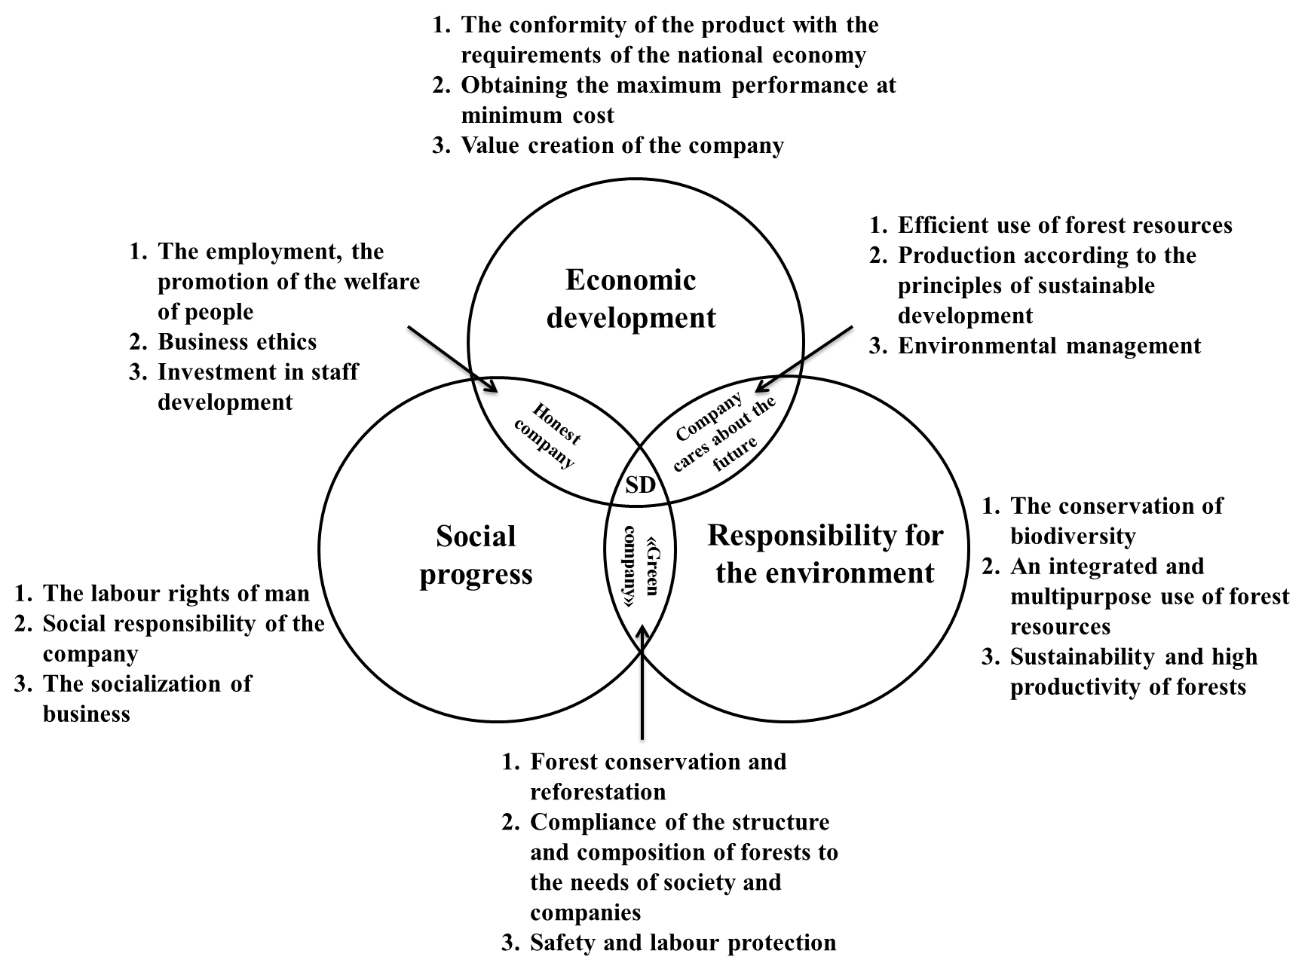

Fig. 1. Triad of the company's sustainable development [1, 8]

The social component of sustainable development is of particular relevance for forestry companies. This is due to the fact that basically forestry companies are located in a relatively small remote monospecialized settlements, cut off from the centers of the region. As a result, the welfare of the population of these settlements is directly dependent on the success of the work carried out by the logging company and its of personnel, financial and technical policy [10].
Undoubtedly, the social responsibility of business requires additional financial cost, but the effect of the social policy will exceed costs [7] due to the fact that the company will remain, a small employee turnover the number of applicants for vacant positions in such companies will be more, hence it is likely recruitment the best specialist who can do the job with minimum of time and money. This will improve the productivity and quality of work results.
For a fuller understanding of the sustainable development of forest companies carry out a comparative analysis of the concepts of "sustainable development", "sustainable development of timber industry" and "sustainable development of the forestry company" (Table 1).

Table 1

Comparison of the different elements of SD systems

The comparison criterion | Sustainable development of global systems |  | Sustainable development of the company
 | planet | forest sector | dynamic | static
Mission | The survival of of humanity in the long term | Maximising the social, economic, ecological effect of timber industry development | Improving the present and future potential of the company | The company's capitalization
Goal | The system of social, ecological and economic goals including rational use of resources, sustainable consumption and production, and others. | Achieving highly productive and sustainable forest condition, max. meet the needs of society and the high social and ecological-economic efficiency | Countering threats to the company at its maximum socio-ecological and economic efficiency | Secure the obligations of the company, increasing the efficiency of its operations (in the narrow sense)
The direction of movement | Dynamic balanced development (upwards) |  |  | Stable condition  (descending)
Components | The social component
 | preservation of social and cultural stability, the development of human and cultural capital | increase human welfare, employment of local people in forest enterprises | respect for human rights, business ethics, to ensure normal working conditions | ensuring normative conditions and minimum working standards
 | The economic component
 | economically optimal use of limited natural resources | max sales, providing full timber processing, max forests yield | эффективное использование ресурсов, max доходности компании, обеспечение полной переработки леса | production and technical, supply and marketing, financial stability
 | The ecological component
 | global stability of the biosphere | ensuring high productivity of forests, the full reforestation | complete reforestation, the use of resource-saving technologies | -
Management
Subject | Supranational structures (UN) | Public authorities of the Russian Federation and the subject of the Russian Federation | the company's management system based on social-ecological-economic goals | the company's management system  based on the hierarchy
Indicators, priorities | The balance of social, ecological and economic indicators |  |  | The dominant of economic factors
Efficiency | Integrated social, ecological and economic efficiency |  |  | Economic efficiency
The crisis condition | The priority of one component to the detriment of others |  |  | Bankruptcy
Source: compiled from [3, 8, 11]

On the basis of comparative analysis can see the continuity and relationship between the sustainable development of the forestry company and the sustainable development of the forest sector. At the same time we can see significant differences between the static stability of the company and its sustainable development. Consequently, these concepts (stability and sustainable development) are not identified, although certain elements of the company's stability needed to ensure sustainable development. We have seen company with a position of the unity of equilibrium combination of (stability) and change (development). However any development aimed at achievement of equilibrium [10]. Accordingly the stability in this case is not the opposite to development, it is characteristic of development.
After level analysis of the category of sustainable development, we get the following logic of its construction (Fig. 2).

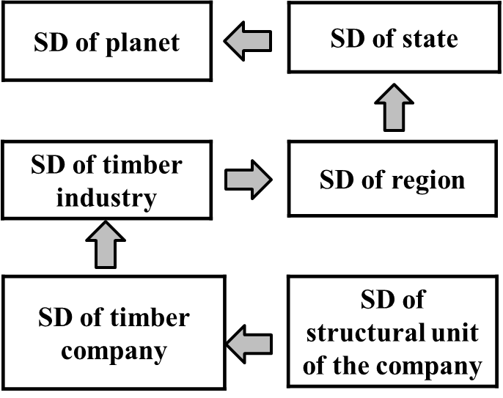

Fig. 2. Schematic diagram of sustainable development

In our opinion, the local level of sustainable development (level of the company) is basic. This is explained by the fact that the company is geographically limited subject that allows strategic and operational control over the processes of sustainable development in ecological, economic and social components. Sustainable development should be from bottom to top by each individual employee of the enterprise in each structural unit to the level of the state. It is impossible to say about fair of the sustainable development of industry, if the majority of companies in it are unprofitable and can not ensure its functioning at the moment or in the future [12].
Adhering to the above logic, we developed the idea of constructing a model of balanced scorecard (BSC) of forestry company [13], which consists in the allocation of structural divisions of companies as the basis for constructing BSC projections, and the inclusion in the model of economic, social, silvicultural and ecological visions. The specified division corresponds to the mission of forest sector and reflects the preferences of the various stakeholders (companies, states represented by the regional governments and local authorities, the public, civil society organizations) in achieving sustainable development.
Accordingly we also formulate the principles of sustainable development of forestry company in the context of strategic management based on BSC (the principle of accounting for all stakeholders, involving grouping the interests of all forest stakeholders; the principle of continuity of the implementation of the company's strategy, which consists in the simultaneous implementation of the strategic and tactical management of the organization, allocation in BSC tactical and strategic goals and targets; participatory principle involves having in the development and subsequent implementation of BSC of all employees; information transparency development and implementation of BSC; the principle of an integrated sustainable development in the development of BSC, involving implementation of the organization of social, ecological and economic sustainability at each hierarchical level; the principle of harmonization of interests of participants of forest relations, goals and indicators, as well as measures for the realization of these objectives; principle of preaktivism consists in the orientation of the long term development of the company) and consider the application of these principles in the BSC of forest complex and forestry companies different forms of ownership [12].

Table 2

Features the implementation of sustainable development principles
in the BSC of forest complex and companies of various forms of ownership

Principles of sustainable develop-ment | The implementation of the principles in the BSC
 | forest complex | forestry company
 |  | public organization | the state unitary and state-owned enterprises | privately owned company
Harmonization of processes, activities, interests of all participants | grouping the interests of all forest stakeholders | consistency of performance indicators with the interests of members of the public organization, their strategic goals for the common good | harmonization of indicators activity of the enterprise, actions with the strategic goals of the state and local authorities, which are founders for this organization | the consistency of the company's activities, actions with the strategic goals
The account of the specificity of develop-ment | account of all aspects of activity from the perspective of the chosen strategy of forest sector development;  social, ecological and economic balance | social and ecological balance of the organization, the economic balance in terms of costs of the organization | account of all aspects of activity from the perspective of the chosen strategy of development of forest complex, region, state | socio-ecological-economic balance in the development, definition factors of competitiveness of the company
The presence of causal relationships | between objectives and measurable empirical-inductive indicators. | between current actions and their consequences as a basis for the implementation of the development strategy | between the current performance of the company and the goals of public administration of forest complex as a basis for implementation development strategy, of industry, region and state. | between current performance and set goals as a basis for implementation of the strategy
The hierarchy and the subordination of goals | balancing general corporate purposes with the goals of regional management of forest complex | accordance goals of the organization to personal goals of members | accordance personal goals of employees to common goals of organization and governance goals of forest complex | maximum compliance goals of employees and divisions to common goals the company
Proactivity and flexibility | adaptation to operational changes taking place in the industry in the region and the state | adaptation to changes in the organization's environment due to risk management organization | adaptation to operational changes taking place in the industry and the state by monitoring risks | monitoring and analysis of the external and internal environment of the company to identify risks and preventive responses to them
Information transparency | transparency and availability of information
Integrated sustainable development | account legal, monitoring, human features of forest complex | consideration of socio-ecological orientation of of organization | account legal, monitoring, human characteristics development of the company, timber industry, region and state | account the legal, human, financial, innovative features of the company
Source: [12]

Thus, the sustainable development of the forestry company is a unique strategy for the company, which provides its adaptive socio-ecological and economic functioning independently on various influences, based on the principles of co-evolutionary adaptation and adaptability.
In accordance with the definition in the current business environment sustainable development of the company is impossible without a comprehensive strategy for development of the company and competent strategic management. Sustainable development of forestry companies organically fits into the concept of adaptive forest management and sustainable development in general, as its essential element.

Literature and the sources:

- Резанов, В. К. Адаптивное управление трансформацией и развитием лесопользования / В. К. Резанов. – Владивосток : Дальнаука, 2001. – 351 с.
- Механизмы управления устойчивым развитием лесного комплекса / В. К. Резанов [и др.] ; под ред. В. К. Резанова. – Владивосток : Дальнаука, 2015. – 511 с.
- Резанов, В. К. Управление адаптивным развитием лесного комплекса региона / В. К. Резанов. – Хабаровск : Из-во Тихоокеан. гос. ун-та, 2015. – 235 с.
- Волостных, В. В. Стратегическое управление и фантом «устойчивого развития» / В. В. Волостных, Т. С. Иванкович, А. В. Иванкович // Современные проблемы науки и образования. – 2012. – № 4. – С. 15 – 20.
- Осипова, Е. А. Классификация факторов устойчивого развития лесопромышленной компании. Современные проблемы экономического развития предприятий, отраслей, комплексов, территорий : материалы Международной научно-практической конференции (Хабаровск, 25 апреля 2016 г.) : в 2 т. / Е. А. Осипова ; под ред. В. Ф. Коурова. – Хабаровск : Изд-во Тихоокеанс. гос. ун-та. – 2 т. – 2016. – С. 325 – 330.
- Мейер, К. Живая организация. Компания как живой организм: грядущая конвергенция информатики, нанотехнологии, биологии и бизнеса / Кристофер Мейер, Стэн Дэвис ; пер. с англ. – М. : Добрая книга, 2007 – 360 с.
- Бёрчелл, М. Отличная компания. Как стать работодателем мечты / Майкл Бёрчелл ; пер. с англ. – М. : АЛЬПИНА ПАБЛИШЕР, 2013. – 272 с.
- Развитие производственных систем: стратегия бизнес-прорыва. Кайдзен. Лидерство. Бережливое производство / Под общей ред. А. Баранов, Р. Нугайбекова. – СПб. : Питер, 2015 – 272 с.
- Дерягина, С. Е. Экологический менеджмент на предприятии / С. Е. Дерягина, О. В. Астафьева, М. Н. Струкова, Л. В. Струкова. – Екатеринбург : ИПЭ УрО РАН – УГТУ УПИ, 2007 – 144 с.
- Резанов, В. К. Интегрированная модель системы сбалансирован-ных показателей лесного комплекса / В. К. Резанов, М. В. Шабалина. – Хабаровск : Из-во Тихоокеан. гос. ун-та, 2011. – 239 с.
- Медоуз, Д. Пределы роста: 30 лет спустя / Донелла Медоуз, Йорген Рандерс, Деннис Медоуз. – М. : ИКЦ "Академкнига", 2008. – 342 с.
- Осипова, Е. А. Система сбалансированных показателей в системе методов стратегического управления устойчивым развитием компании лесного комплекса региона. Современные проблемы экономического развития предприятий, отраслей, комплексов, территорий : материалы Международной научно-практической конференции (Хабаровск, 30 апр. 2015 г.) / Е. А. Осипова ; под ред. И. В. Брянцевой, Л. Л. Бияк, И. В. Калашниковой. – Хабаровск : Изд-во Тихоокеанс. гос. ун-та, 2015. – С. 510 –517.
- Осипова, Е. А. Методические основания стратегического управления устойчивым развитием лесопромышленной компании на основе системы сбалансированных показателей / Е. А. Осипова // Власть и управление на Востоке России. – 2015. – № 4 (73). – С. 195 – 201.

