УДК 316.62:316.346.32-053.6

Elena Aleksandrovna Smirnova – Candidate of Sociology, docent of the sociology, social work and the right chair of the Far-Eastern institute of management – branch of RANEPA (Khabarovsk). E-mail: sea221@yandex.ru
Irina Viktorovna Lisovskaya – graduate student of the National research university "The Higher School of Economics" of NIU VShE(SPB), the St. Petersburg school the social sciences and humanities (St. Petersburg). E-mail: ilisovskaya@hse.ru

Adolescents in a difficult life situation: provocation or rehabilitation?

Nowadays the system of specialized institutions for deviant children and adolescents is being developed. The question of how these special institutes affect deviant children and adolescents becomes more and more important for the society. This paper focuses on the students and their deviant behavior in graduating class in the Khabarovsk Rehabilitation Center as a case of this type of institution used. Sociological and psychological methods such as observation, picture states that testing and comparative analyses etc., are used for the research. The paper propensity for deviant behaviors cannot be fully overcome even in a specialized educational institution. The effectiveness of a rehabilitation center depends on many factors and conditions that will be required a further study, so a comprehensive study of this phenomenon throughout the whole country is necessary.

Подростки в трудной жизненной ситуации:
вызов или реабилитация?

Авторы в статье отмечают, что с развитием системы специализированных учреждений открытого типа для девиантных детей и подростков актуальным становится вопрос о том, насколько эффективными являются данные учреждения в регионах России. В статье акцентируется внимание на выявлении степени преодоления склонности к девиантному поведению у подростков выпускного класса на примере реабилитационного центра в г. Хабаровске. Данный критерий является главным показателем эффективной работы центра. В исследовании использованы социологические и психологические методы, в частности: наблюдение, рисуночное тестирование и сравнительный анализ, – которые позволили авторам сделать вывод о том, что в специализированном учреждении г. Хабаровска склонность к девиантному поведению преодолена не в полной мере. Эффективное действие реабилитационного центра зависит от многих факторов и условий, которые необходимо продолжать комплексно изучать не только в рамках региональных практик, но и охватывать все регионы России.

Keywords: specialized educational institutions, deviant behavior, juvenile delinquency, youth in difficult life situation, offense, crime, anti-social phenomena, neglect, correction, education, control of unmanageable teenagers.

Ключевые слова: специализированные образовательные учреждения, девиантное поведение, подростковая преступность, молодежь в трудной жизненной ситуации, правонарушения, преступность, антисоциальные явления, безнадзорность, коррекция, воспитание, контроль «трудных» подростков.

The problem of child neglect and juvenile delinquency is relevant for our society. A child since birth needs constant pedagogical accompanied in the way of moral, intellectual, physical, and professional development. Lack of support or inadequate support from adult’s inevitable transformed into child neglect which is the basis for the formation of the infringing behavior of minors. Education of citizen in a state cannot be effective without the involvement of all public and state institutions including family, educational institutions, law-enforcement system, judicial bodies and other institutions that form the legal sense of justice and behavior of the individual.
According to the statistics for 2012 and 2013, there was is an increase in juvenile delinquency. The number of criminals among teenagers (14 – 15 year old) increased by 1.2 thousand people and among students (16 – 17 year old) increased by 1.7 thousand [2]. By law, juveniles are usually sent by the court into the correctional institutions. This practice is not positive, since it violates their social relationships and causes the formation of social exclusion. Therefore, the development of the open-type educational institutions is the most humane choice for those deviant children and adolescents. According to the data from Ministry of Home Affairs of the Russian Federation notice the growth of juvenile crime among minors (crimes weight in 2012 – 52 203, in 2013 – 55 641). 174 thousand of adolescents are registered in police [1].
In Russia, there is a system of specialized open-type educational institutions, enshrined in law since 1999. According to recent reports, there is a reduction by 15% the number of adolescents directed by the court in a closed institution [4].
However, in the literature there are few studies about the problems of a specialized open-type institutions. Most studies focus on the problems of closed type institutions. Thus, the question remains open about the open type institutions, their activities and daily practices among adolescents with in the institution.
Аcording to data for 2013, 20 specialized secondary institutions of various kinds of acts in the Khabarovsk Territory [5]. Besides, set of measures for the prevention of child neglect, offenses, bad habits in the Khabarovsk region at the end of 2014 contributed to the reduction of the crime proportion among minors for 1,2% and reached 7.6% (8.8% in 2013). The amount of crimes committed by minors still high in the Khabarovsk region 1177 [6] and in Saint-Petersburg 768 crimes [7]. In 2014 the level of minors crimes in Saint-Petersburg equaled 2,8% at the all-Russian – 5%. This statistics, allows to state that the system of the prevention of child neglect and prevention of child crimes is not effective in regional aspect. According to this fact, there is a problem of regional crime prevention practices in open-type schools. The main thesis of this paper is that the effectiveness of rehabilitation centers for deviant adolescents in the most remote regions can be improved.
This paper focuses on the study of problems related to the prevention of neglect and deficiency in the Khabarovsk region: the case of the non-stationary activity center of Rehabilitation and Correction. The main research question is: how effective is the work of psycho-pedagogical non-stationary center Rehabilitation and Correction to overcome the tendency to deviant behavior in adolescents in Khabarovsk?
The focus of the study is the examination of the deviant teenagers who are students of a specialized institutions of an open-type "Khabarovsk Psychological and Pedagogical Rehabilitation and Correction Center."
Subject of special education is becoming increasingly important. The greatest attention should be given to interpretation of special education as a special system. The experience of the USSR, where the system of Special Education and Special Educational technology was fixed in the 20-ies of the 20th century is a subject of a great interesting. The special education system can be defined by a number of factors in the Former Soviet Union. The First World War, Revolution and The civil war had serious the most tragic impact on the system of educational. As a consequence of these internal political processes, there was a huge number of homeless people and neglect children, which was a 7 million people in 1922. Secondly, the development of the social sciences, the study of personality, and theoretical & practical research in the field of education under the influence of Freud's theories, Morel, Lombroso played the special part. Another significant factor is the concept of the Soviet state. It was envisaged that the state was responsible for providing treatment and care for all children. High social responsibility of the communist system could not allow street children exist outside of the state. Thus, after the formation of the Soviet Union in 1922, there was a question of socialization of deviant children [8].
The idea of ​​special education had been developed for 2-nd Congress of the Communist Party, which presented ideas of Vygotsky, Lagovsky and other scientists, regarding special education for the disabled. The idea of creating a specialized school for juveniles found its development in the ideas of Makarenko and Vygotsky. Colony Gorky is the first attempt to create a special crime prevention system for adolescents. Its activities are based on the renunciation of the use of incarceration. The fact that the team lays the groundwork for re-personality was confirmed. Gorky Colony Experience has shown that the collective work as the main method of rehabilitation and socialization in connection with education brings the most significant results [8]. This experience can be considered unique. At first in the USSR juvenile offenders were placed in an open rehabilitation and it had brought positive results.
The study of specialized institutions for delinquent and deviant teenagers was launched in the early 50th of the 20th century in the USA. The American experience is a longitudinal study of open and closed specialized schools, revealed interesting facts. School of an open type (Lyman) actively used the therapy and rehabilitation technology. Because of the monitoring data the pupils and graduates of the school to the age of 24 showed that students of the school were less likely to relapse of crimes. In addition, they had medium and high scores in learning and a lower propensity for deviant behavior. School of a closed type (Wiltwyck) used harsh methods of correction with respect to the students. After the release the students were more prone to criminal acts. However, the results of the twenty-five year follow-up research showed that the measures of an open school are valid only until the age of 24 graduates. After the onset of this age the situation changes dramatically. Graduates tend only to relapse to 24 years, then there is a reduction in crime [9].
Investigation of the dynamics of teenage groups as an example of using negative practices (use of psychotropic substances and nicotine, aggression, etc.) confirms the fact that the use of drugs or alcohol at an early age in the company of peers leads to increased dependence in older adolescents [10]. In addition, foreign studies using the method of interview is an analysis of the specialized school activities in terms of alumni, where students maintained social ties with the outside world during their training and rehabilitation. Most of the respondents were of good opinions about the school and noted the effectiveness of a number of practices, such as volunteering and work activities. However, negative manifestations of everyday life in the form of mobbing and aggression also remained.
Thus, the literature review shows that the formation of a specialized education for teenagers with behavioral problems began in the early 20th century. The first studies of the effectiveness of this system began in the second half of the 20th century. The special education system exists a dichotomy between open and closed institutions. Modern research confirms the idea and the concept of open-type institutions is very humane, but has a number of problems in the organization of its activities.
The main purpose of the analysis is to identify the level of deviant behavior to overcome the tendency of students in the institution of an open type. This figure is a key for the analysis of effective activity of the rehabilitation center.
For the study of deviant behavior and characteristics inherent to it (aggression, anxiety levels), as well as individual personality characteristics and tendencies, self-graduating class of student’s practical research was carried out. 10 adolescents aged 14 to 16 years were the Participants of the study. The study was carried out in "The Khabarovsk Regional Centre for Psychological and Pedagogical Rehabilitation and Correction" and took several stages [12]:
At the first stage the main goal was to get a general idea of the team of students, the formation of a social portrait class. The main research method used at this stage was nonparticipant observation. Selected problematic situation for the application of this method is a lesson conducted by a teacher. The observation is external fixation reactions of children according to certain criteria. The verbal and non-verbal behavior, interpersonal interaction of students, relationships with peers and adults were observed in this class.
Data has shown that the ratio of children to educational activity can be largely defined as indifferent. There is a low interest for the lesson. Two children showed open forms of reluctance to assimilate the material (sleep on the desk during class, the lack of reaction to the teacher's notes). In the team there is a child-disorganizer which somewhat hinders teach and distract other students. In the classroom there is a leader who has a great influence on the whole team. The teacher becomes the object of rude unrespectfull. Verbal behavior can be assessed as satisfactory for this age period, for this category of adolescents. There is verbal aggression, raising voices, ignoring the use of harsh words and slang. Non-verbal behavior is considered to be satisfactory. This is manifested in the lack of distance between teenagers, violation of personal boundaries, frequent physical effects, manifested in jolts and blows.
Another method of the research is the use of projective picture testing "nonexistent animal." The purpose of the study is the diagnosis of personal characteristics of a teenager, studying the level of anxiety, aggression, self-esteem, relationships with the environment, the degree of adaptation of the child in the team. Proposed material here is a set of items: easy medium hard pencil, a sheet of A4 size paper.
10 pupils survey analysis can be considered in terms of two criteria: the criteria for manifestation of personal characteristics and performance of adaptation of teenagers. The data obtained by the first criterion can be displayed in the figure 1 below.
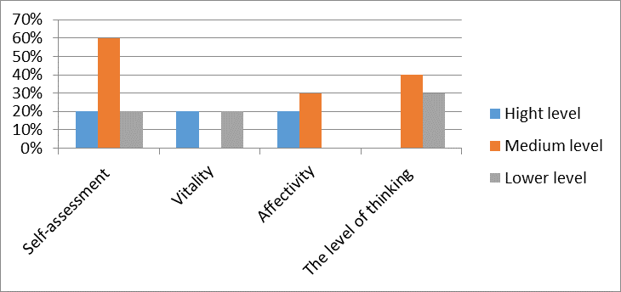
Fig. 1.

The histogram shows that 60% of teens has the normal rate of self-assessment, 20% show low rate, 20% of students has high self-esteem. Active life position and tendency to action is observed in 20% of the students, the tendency to reflection and low vitality in 20%. 30% have elevated affect, but to cope with control over their judgments and actions, 20% of children are poorly to control themselves. 40% tend to prone to rational thinking, inherent soundness of judgment. The banality of thought is seen in 30% of adolescents.
The next criterion on which testing was conducted is a level of adaptation of teenagers.
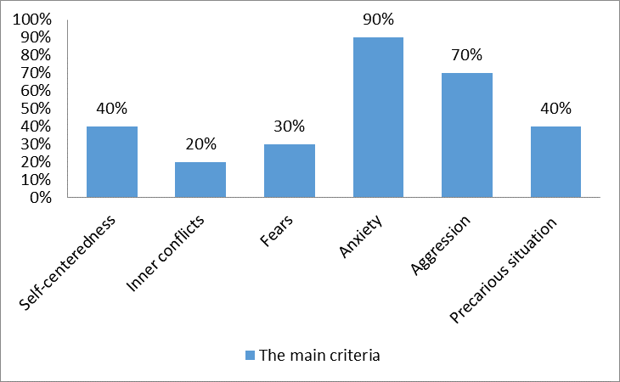
Fig. 2.

Egocentric traits have 40% of the children, which can be interpreted in a particular situation. The presence of internal conflicts is observed in 20% of patients, 30% of adolescent’s experience persistent fears. The presence of high level of anxiety is observed in 90% of adolescents, 20% of which have a high level of anxiety. Manifestation of aggression of various kinds tend to 70% of teens, 20% of children experience fear of aggressive-minded comrades. 50% of children use verbal aggression. 20% show protective aggression towards adults in the face of parents and teachers. 30% of teenagers are prone to aggressive defensive reaction against aggressive peers. Teens who feel the uncertainty of their situation in life, precariousness of the situation is 40%.

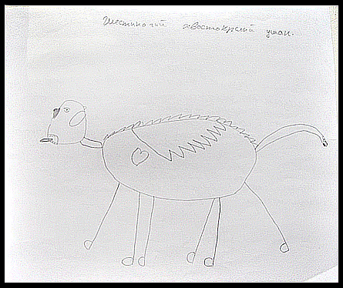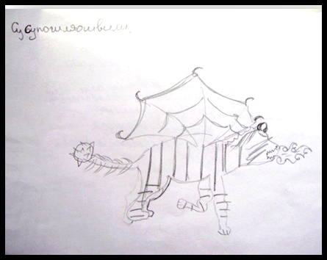

Fig. 3.

The analysis can be carried out on the basic parameters on the basis of the received data and diagnostic centers monitoring this class of data within 3 years: the level of anxiety and aggression of pupils. The average data were taken for the analyses. They are shown in Figure 4.

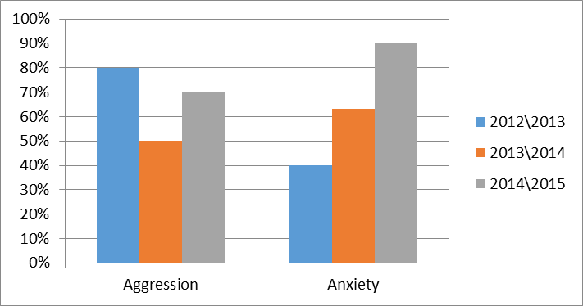
Fig. 4.

According to the study, the average level of anxiety for graduating class students demonstrate significant growth every year. The level of aggression is much higher, but not exceeding the primary indicator.
Audience research on the graduating class teenagers with deviant behavior, consisting of psychological and pedagogical support, had been carried out for three years in the Khabarovsk regional psycho-pedagogical center of Rehabilitation and Correction, and found that the percentage of overcoming the tendency to deviant behavior is not high. The use of surveillance at the primary stage of the study showed that the interest in learning activity is absent, relationships with adults and peers can be called satisfactory and strained. Also, there is a manifestation of aggression to each other, even in the presence of adults. The test method was used of at the second stage of work. The following indicators have been diagnosed: a high level of aggression (70%), which manifests itself with regard to both peers and adults, and an increased level of high anxiety in 90% of cases. Many teenagers are experiencing self-doubt, inner fears, the precariousness and uncertainty of their situation and the future (40%). Comparative analysis with the use of the three years of monitoring data showed that the phenomenon of school exclusion and propensity to partially overcome by deviant behavior. However, despite these results, the relapse rate in this facility is about 3 – 5% [11], which means that the daily practice of teen communication (a combination of positive and negative daily activities, expressed in the interaction of individuals) remain an important issue for researchers.
The system of daily practices of adolescents is a contradictory trend. So, on the one hand, there is a process of socialization and rehabilitation, and the process of formation of positive rules, but on the other hand there is a consolidation of destructive practices among adolescents. In addition, this problem is particularly acute in the most remote regions, such as the Khabarovsk region. The low percentage of effective action to prevent child neglect and delinquency in the region is backed by the facts of the study. Thus, the problem of lack of effectiveness of preventive measures is identified by using the analysis of effectiveness of the institution in accordance with this methodology. This phenomenon exist due to a number of factors that should be investigated further. For example, you can expect to influence a number of social practices inside these institutions on the effective operation of the whole system of specialized education open type.

Literature and the sources:
- Основные статистические данные по вопросам защиты прав и интересов детей (2009 – 2013 гг.) : стат.данные [Электронный ресурс] / Уполномоченный при президенте РФ по правам ребенка. –.– Режим доступа: http://rfdeti.ru/files/StatData-2014-aug.pdf
- Состав лиц, совершивших преступления [Электронный ресурс] / Федеральная служба государственной статистика. –.– Режим доступа: http://www.gks.ru/bgd/regl/b14_13/IssWWW.exe/Stg/d02/11-02.htm
- Концепция федеральной целевой программы «Молодежь России» на 2012 – 2016 [Электронный ресурс]. –.– Режим доступа: .https://www.google.ru/url?sa=t&rct=j&q=&esrc=s&source=web&cd=13&ved=0ahUKEwijvfLElL3LAhUhEpoKHa0OB8gQFghRMAw&url=http%3A%2F%2Fkurganoblduma.ru%2Fupload%2Fiblock%2Fbcf%2F1296821285.doc&usg=AFQjCNGbEdAyM31A4F5yl0AG6il-sLjVTw&sig2=eisTLlBjsNnFGxdiUyIAfg
- Число лиц, содержавшихся в местах лишения свободы [Электронный ресурс] / Федеральная служба государственной статистики. –.– Режим доступа: http://www.gks.ru/bgd/regl/b14_13/IssWWW.exe/Stg/d02/11-11.htm
- Сведения о специальных (коррекционных) образовательных учреждениях для обучающихся, воспитанников с ограниченными возможностями здоровья и оздоровительных образовательных учреждениях санаторного типа для детей, нуждающихся в длительном лечении [Электронный ресурс]. –.– Режим доступа: http://минобрнаукирф/%D0%BC%D0%B8%D0%BD%D0%B8%D1%81%D1%82%D0%B5%D1%80%D1%81%D1%82%D0%B2%D0%BE/360/%D1%84%D0%B0%D0%B9%D0%BB/3305/%D0%94-9%20%28%D0%93%D0%9E%D0%A3%29_23012014.xls
- О результатах анализа состояния и перспектив развития системы образования Хабаровского края за 2014 год: Итоговый отчет Министерства образования и науки Хабаровского края / Министерство образования и науки Хабаровского края. –.– Режим доступа: http://edu27.ru/files/4445_monitoring_sist_obrazov_hk_za_2014.pdf
- Официальный сайт администрации Санкт-Петербурга [Электронный ресурс]. –.– Режим доступа: http://gov.spb.ru/gov/otrasl/c_zakonnost/news/60275/
- Csapo, M. Special Education in the USSR Trends and Accomplishments // Remedial and Special Education. – 1984. – Т. 5. – №. 2. – С. 5 – 15.
- McCord W., Sanchez J. The treatment of deviant children: A twenty-five year follow-up study // Crime & Delinquency. – 1983. – Т. 29. – №. 2. – С. 238 – 253.
- Polat F., Farrell P. What was it like for you? Former pupils’ reflections on their placement at a residential school for pupils with emotional and behavioural difficulties // Emotional and behavioural difficulties. – 2002. – Т. 7. – №. 2. – С. 97 – 108.
- Петрынин, А. Г. Психолого-педагогические технологии в реабилитации детей с девиантно-криминальным поведением / А. Г. Петрынин // Психологическая наука и образование. – 2013. – № 1. – С. 94 – 103.
- Список воспитанников Центра психолого-педагогической реабилитации и коррекции г. Хабаровска, состоящих на учёте в ПДН в 2014 – 2015 уч. год : отчет / Г. Н. Агеева // КГБОУ «Хабаровский краевой центр психолого-педагогической реабилитации и коррекции». – 2015.

