Vladimir Alexandrovich Povstin – director of JSC «Vostochnaya Torgovaya Kompaniya» (Khabarovsk). E-mal: vtkcompany@yandex.ru

Social capital use within the economy of the Far East

The article deals with the social capital and gives peculiarities of its origin within social networks. It also describes mechanisms of raising the level of social capital in an organization. The author shows the significance and benefits of efficient social networks usage and how important is to use their social capital.

Keywords: social capital, social networks, lobby, social network resources, organization boundaries, couching, capital conversion, investments, business.

Socio-economic problems in the crisis conditions, strategies of small and average business development in the Far East of Russia are the problems of today. Peculiarities of economic development in the Far East have been repeatedly discussed in theoretical works. The market in the Far East is well developed and rather big, the territory is rich in natural resources, nevertheless considerable difficulties exist here that restrain investment process [7]. Local authorities’ support can hardly be expected, neither can we rely on the investors. Budgets have been approved with deficit, enterprises’ provision for taxation has reduced and the budget receives less tax money. Under these circumstances people of the Far East have only themselves, their own social networks and social resources to depend on. Accumulation of social capital means a great number of expenditures during a long period of time: resources, knowledge, competence and ability to assess events and prospects strategically. The result of the author’s involvement into the social network is information, support, lobby, etc., in other words, various benefits received thanks to our personal contacts.

It would be a mistake to consider social capital as one from the list of conventional capitals, such as physical, financial and money capitals. Social capital has always been converted from cultural, economic, power capitals and the like. Otherwise it would start subsiding. Pursuit of complete capital reproduction can be the base for strategic development by means of capitals conversion [1]. Effectiveness of social capital working can be revealed only if the connection between this resource and other kinds of capital keeps increasing and is easily seen. While in the middle part of the 1990s we could not expect the ethic component to grow neither in business nor in the society, at present corporate management is based on decency, integrity and reliability of partners. We need to have a high level of trust in suppliers, manufacturers, executors and consumers, which is not possible outside certain social network. The above said makes open sectoral conferences and round table discussions necessary. Direct discussion of problems and prospects unites the participants into integrated sectoral network, whose social capital can serve their interests.

On the one hand, social capital studies are caused by the necessity to raise the quality of life of the Russian society, and not at the expense of increase in sales at the world raw materials markets, but by means of developing and implementing new programs of adoption of innovative technologies. On the other hand, in our country business has to procure services of the authorities of all the ranks regularly. The officials’ decisions and how soon they are implemented have certain price, which depends on the social network of the person or entity that needs the authorities’ services [2]. The concept of “lobby” should be mentioned here. The more you trust the official, lobbying for your interests, the sooner and with more benefits your problem is solved. The number of persons, who are able to lobby for one’s interests where the decisions are made, not free of charge as a rule, shows the efficiency degree of social capital that one’s social network has. The role of a mediator between a subject and authorities is essential. The relations between business and its own social network should be manifested in the role of business social policy programs. If social issues and problems are included into social programs the company personnel can become united, that can increase social capital. Though there is an opinion that capital investment in human resource is a thankless task, there exist sufficient reasons for social issues inclusion into the general concept of business development.

In the environment of mutual confidence and mutual aid additional networks resources can be activated. Growing confidence will make it possible to use delicate management techniques, that are not used or if used are not effective, in the atmosphere of distrust. According to Finish scientists R. Blom, G. Melin, A. Sarno and I. Sarno, the companies whose managers were able to establish trust relationship with social environment subjects, get a real advantage – more diversified and modern management [3]. The confidence level of large sectoral businesses to the authorities is rather low that up to the present has been causing capital flight abroad. Social capital of particular business can be part of a branch, region and country and be aggregate social capital of the state. The majority of social environment subjects pursue their own interests in a straightforward and plain manner, ignoring other subjects’ interests of the same social environment. Like any other kind of capital, confidence can be converted into different values and participate in communication and reproduction processes.

Under existing conditions success, development and profit of a company in the first place depends on a well-coordinated and united team and also on internal and external communication. All this is possible only if the territory is developing dynamically. There are some factors that make it difficult to solve socio-economic problems in the Far East: the changing nature of the culture here, the territory is far from the centre and the centre has no clear view of the territory problems.

Social capital can be multi-faced and diverse, having both positive and negative influence on the society. For example, undoubtedly high degree of social capital of criminal community is good for its group members but bad for the society in general.

Only recently the concept of social capital has widely spread in economic and sociological science. There has been more and more evidence lately that social unity is the determining factor of economic well-being of the territory, sustainability of society and some of its elements. Social capital is not just a set of institutes supporting society, but rather a kind of “bonding material” that keeps together its various parts. First of all horizontal ties between people constitute social capital, it also includes social networks and adequate standards, that have effect upon productivity and well-being of different communities.

Social capital can be demonstrated clearly by means of microanalysis with calculation of resources exchange between households classified by income level [4] that will show what volume of cash resources Far Eastern citizens are ready to give and expect to receive.

To make calculations 750 households were surveyed. To construct a network model a group of households presented the vertices of network by income level per head in the family. Thus four groups were determined:
- The poorest households, average per head income is less than 5 000 rubles.
- Low-income households, average per head income is from 5 000 rubles up to 12 600 rubles.
- Average households, average per head income is from 12 600 rubles up to 24 400 rubles.
- Wealthy households, average per head income is more than 24 400 rubles.
Cash flows are calculated according to the resources exchange algorithm. Unit of measure is rubles. All the flows having been calculated a flows quantity matrix is constructed for each vertex, where rows (i) near the vertices show flows running out of the vertex, and columns (j) show incoming flows, “eij” shows outrunning from the vertex “i” flow quantity and running into the vertex ”j”.
Table 1

Calculation of exchange cash flows for households with different income levels all over the array for 2008

 | j | 1 | 2 | 3 | 4 | Money given, % | Money received, %
i | еij | +146657 | +181814 | +297443 | +739056 | Money given, % | Money received, %
1 | -85552 | 9192,078 | 11395,54 | 18642,78 | 46321,97 | 36 | 46
2 | -85305 | 9165,543 | 11362,64 | 18589,01 | 46187,88 | 23 | 21
3 | -163183 | 17532,91 | 21736,06 | 35559,38 | 88354,83 | 26 | 18
4 | -490144 | 52662,78 | 65287,07 | 106808 | 265385,7 | 15 | 15

In the column «Money given, %» the income share is reflected, given to other people at the average. In the column «Money received, %» the income share is reflected, received from other people at the average. As the Table shows, the sum of money given by the first and the poorest group of households is not large: 85 552 rubles, whereas the fourth and the wealthiest group gives 490 114 rubles. Nevertheless it comprises 36% of all their income, but only 16% for the latter.
Flows of more than 18 000 rubles will be included in the net model. The net model for the whole of the array is shown in Figure 1:
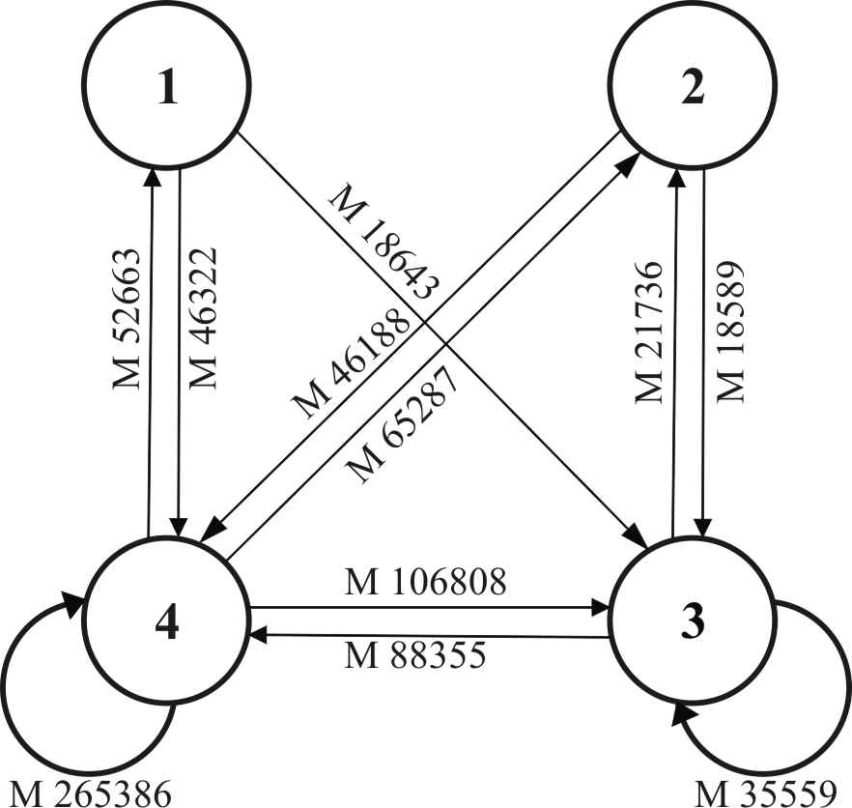

Fig. 1. Exchange cash flows for households with different income levels calculated for the whole of the array for 2008 (750 households, 2008)

It can be said that the flows connecting the vertices are stable, since approximately equal flows go into both directions. It should be noted, that the most intensive exchange takes place among wealthiest households 3 and 4. Low-income and poor households 2 and 1 do not exchange money. According to the model (Table 1) even the aid to poorer households is not one-way flood, approximately equal flood goes in the back direction.
The wealthiest households are involved in the cash flow most intensively. As a matter of fact they are the major redistributors of money transfers, according to the network terminology this position is called “mediator”.

To get a better understanding of social capital with its “goods” and “bads” one should study not only horizontal but also vertical ties among people, functioning of organizations and relations among them [5]. Such approach takes into consideration the fact that horizontal ties provide groups of people with identity and community of goals. At the same time it emphasizes that if there are no ties connecting different social groups (such as religious, ethnic, socio-economic) in-group ties can cause pursuit of narrow interests and become an obstacle on the way to information and material resources, that otherwise could be a great support for the community.

Social capital has some characteristic features characteristic of other forms of capital, especially human capital. However social capital differs from other forms of capital. Unlike other forms of capital social capital is embodied in social relations of subjects but not in particular subjects or objects [1]. On the basis of the above said social capital is not owned by the subject using it. Like other forms of capital it is a long term asset which needs investments to be saved and renewed. However, social capital differs from other forms of capital because it is really impossible to evaluate investments in its development in terms of quantity. Social capital increases while being used, like human capital and some public goods.

From our point of view the assertion that social capital in Russia is the transformed notion of the Soviet period “blat” into post-soviet “corporativity” is only partially true [6]. The notion of “blat” in the soviet society meant possibility to get access to public goods: commodities, services, income sources (education, working places, positions, etc.) and privileges avoiding formal procedures, regulating access to resources of personal consumption. In the environment of today the notion of “blat” no longer includes all the variety of informal relationships, the way of using connections has become more diverse and the result of using connections has diversified too.

Whereas “blat” or “backstairs influence”, being a network resource, took place primarily in the distribution sphere during the Soviet time, now the network resource and social capital as the result of the resource effectiveness, works on all authority levels and in all economic spheres. Modern concept of social capital has appeared in Russia, it grew out of the “Soviet blat” concept and has turned into the modern notion - corporativity. The term “corporativity” is used to denote “being one of the group”. It’s easy to understand the logic of corporativity, i.e. to deal with those who are “one of the group” and support them [6]. To ascertain that nowadays corporativity is for those who are “one of the group”, who have been tried and true, is possible in any sphere, where decisions are taken on the distribution of resources, or on choosing contractors and suppliers. For remote territories to be united by means of large corporations is a move in solving Far Eastern problems. But the tendency, occurring everywhere, to become a part of Moscow networks and corporations will not solve the problem.

All major operations, any tender, auctions, financial fraud, investment projects – all that is based on former ties and mutual trust mainly. In the “blat” environment of the Soviet period benefits received were not as a rule of material-financial character but were based on mental and ethical reasons. “Soviet blat” has taken the form of bribery of various types. Corruption of officials making decisions plays into their own hands and into the hands of their close circle as well and the desired is received at a lower cost. All levels of power are pierced with social capital negative developments of corruption character. Corruption has been acquiring some modern image, where a benefit is expressed not by a classic bribe but in lobbying those whose victory is in the interests of the alternative subject himself/itself. One mustn’t assert that social capital works only in the corruption environment, but on may insist that the larger part of shadow economy is based on network resource.

Business networks members are served inside the network on special terms, that are, as a rule, of non-market nature but they pay for being part of the network with return commitments. Russian business ethics is formed within the framework of business networks. Network outsiders don’t bear expenses on constructing business networks around themselves or on overcoming obstacles when entering already existing networks. But on the other hand they pay for transaction costs of any deal at the maximum price including the risk of unpredictable behavior of unknown partners [2].

The role of social capital becomes evident especially when formal institutions don’t work, but if they work they have elements of shadow activity. Therefore it’s natural that “trust” based mechanisms arouse more and more interest in Russia particularly now, when society and business and the state itself witnessed low quality of operation of the government, lawmakers, courts and law enforcement bodies.

Ability to gather all the capitals by their components into cumulative capital and to turn the networks’ social resource into social capital is our task. At present it is essential to be able to use social networks, find approaches to connections and ties network. The established and lasting in-group relations lead to the community members’ positive attitude to their place and work since they like those they are interacting with.

Some still argue that social capital indices are not valid enough and constructs are hardly measurable and recommendations are inarticulate. This article addresses those who set themselves the task to lose less and gain as much as possible during the crises period. It’s time to stop considering social capital an aspect of socio-psychological relations of in-group members, it is necessary to see it as a constituent component of cumulative capital.

Literature and the sources:

- V. V. Radaev. Capital, forms of capitals and its convertation // Economic sociology. – М., 2002. – № 4.
- S. Yu. Barsukova. Shadow economy and shadow policy // Russia. – М., 2006. – № 3.
- R. Blom, H. Melin, A. Sarno, I. Sarno. Management in modern Russian industry // Russia. – М., 2004. – № 6.
- G. V. Gradosel’skaya. Measurement in sociology: textbook / Under red. Of G.S. Batygina М.: «New textbook». – М., 2004. – 248 p.
- I. E. Diskin. Social capital in global economy // Social sciences. – М., 2003. – № 5.
- A. Ledeneva. Non-formal sphere and “blat”: social society // Pro et Contra. – 1997. – Т. 2 № 4.
- V. G. Norin. Investment attractiveness of the Far East of Russia: evaluations and prospects // Scientific annual of FEAPS. – Khabarovsk, 2008. – 5.

“blat” means “backstairs influence/pulling strings/using connections” [interpreter’s note]

